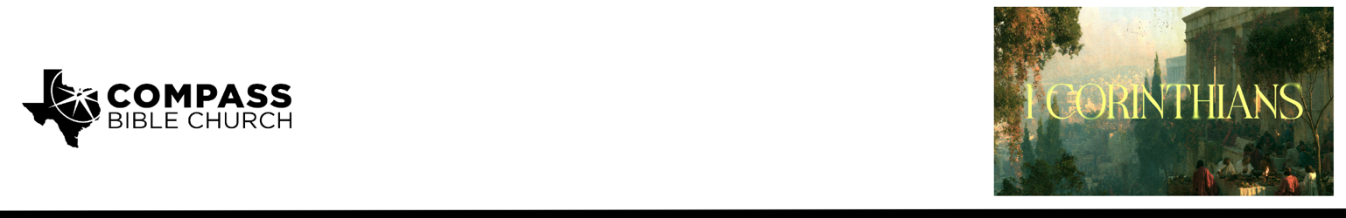

Pastor PJ Berner • October 25, 2026

Philippians 1:12–18 | The Unchained Gospel

Scripture Memory
Now we have received not the spirit of the world, but the Spirit who is from God, that we might understand the things freely given us by God. –1 Corinthians 2:12

Community Group Discussion Questions
Community Groups meet throughout the week and play a crucial role in our response to the preaching of the word. These groups gather to discuss the following questions as we seek to apply the sermon in community with one another. Please visit compassntx.org to join a small group near you.

1. Read Philippians 1:12. What are some unique or trying circumstances in your life that God has used to advance the gospel in unexpected ways? What might he be doing presently in your life to give you gospel opportunities?

2. Read Philippians 1:14 and Luke 12:4–5. What fears most often keep you from sharing the gospel? How should confidence in the Lord and a proper fear of God change the way you respond to those fears?

3. Read 1 Corinthians 15:1–4 and Galatians 1:6–9. What distinguishes the biblical gospel from a distorted gospel? How can we maintain strong theological convictions while genuinely rejoicing when Christ is faithfully proclaimed by churches that differ from us on secondary doctrines?

4. Read Philippians 1:12–14. Whether during Outreach Week or in your normal routines, what is one specific opportunity you could pursue this week to help advance the gospel? What would it look like to approach that opportunity with bold confidence in the Lord?

Recommended Reading

Here are some books that may help you with a deeper study of the truths presented in today’s sermon. While we cannot endorse every concept presented in each book, we do believe these resources will be profitable for thinking through today’s topic.

• The Gospel and Personal Evangelism — Mark Dever
• Evangelism: How the Whole Church Speaks of Jesus — J. Mack Stiles
• Through Gates of Splendor — Elisabeth Elliot

