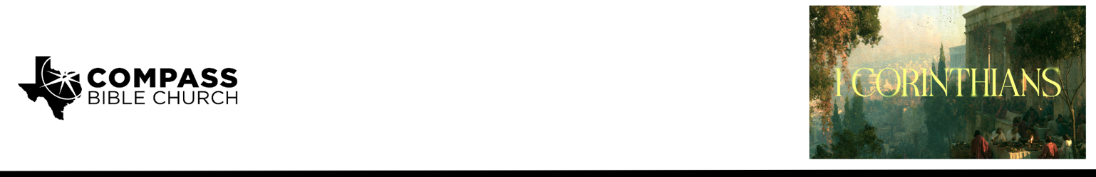

Pastor PJ Berner • October 4, 2026

1 Corinthians 2:6–13 | Why the Bible Makes Sense (If It Does)

Scripture Memory
Now we have received not the spirit of the world, but the Spirit who is from God, that we might understand the things freely given us by God. –1 Corinthians 2:12

Application Questions
Community Groups meet throughout the week and play a crucial role in our response to the preaching of the word. These groups gather to discuss the following questions as we seek to apply the sermon in community with one another. Please visit compassntx.org to join a small group near you.

1. Read 1 Corinthians 2:6–7. Paul assumes that believers should progress toward maturity. Where are you most tempted to become complacent in your spiritual growth? What would pursuing greater maturity look like for you right now?

2. Read 1 Corinthians 2:10–13. We affirm that the Spirit inspired the Scriptures and illuminates believers to understand them. What are some ways we can functionally approach Scripture as though understanding it depends primarily upon our intelligence, education, study methods, or resources? What would genuine dependence upon the Spirit look like without diminishing the importance of careful study?

3. The Corinthians possessed significant knowledge and spiritual gifts, yet Paul will soon describe them as “infants in Christ” (1 Corinthians 3:1). What does that teach us about the difference between biblical knowledge and spiritual maturity? What evidence in your own life would demonstrate that what you know about God is actually producing maturity?

4. Think of a biblical truth that you once struggled to understand, believe, or appreciate but that has become clearer or more precious to you over time. How did the Lord use His Word to change your understanding, and what difference has that truth subsequently made in the way you live?

Recommended Reading

Here are some books that may assist you in a deeper study of the truths presented in today’s sermon. While we cannot endorse every concept presented in each book, we do believe these resources will be helpful in profitably thinking through today’s topic.

• A Call to Spiritual Reformation by D.A. Carson
• The Holy Spirit by Sinclair Ferguson
• Habits of Grace by David Mathis

