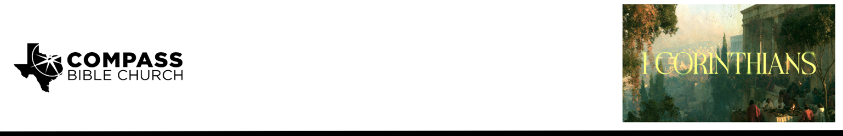

Pastor Rod Gomez • September 27, 2026

1 Corinthians 2:1-5 | The Not-So-Secret Sauce of Paul's Evangelism

Scripture Memory
And because of him you are in Christ Jesus, who became to us wisdom from God, righteousness and sanctification and redemption, so that, as it is written, “Let the one who boasts, boast in the Lord.” – 1 Corinthians 1:30-31

Application Questions
Community Groups meet throughout the week and play a crucial role in our response to the preaching of the word. These groups gather to discuss the following questions as we seek to apply the sermon in community with one another. Please visit compassntx.org to join a small group near you.

1. Read: Acts 17:16–17. Paul went to the Corinthians instead of waiting for them to come to him
(1 Cor 2:1). Where in your normal week (think: barber, delivery driver, neighbor, checkout line, etc.)
could you start a gospel conversation? What usually keeps you from starting one, and how can you overcome that?

2. Read: 1 Thessalonians 2:3–8. Paul deliberately refused “lofty speech” and “plausible words of wisdom” (1 Cor 2:1, 4). When you talk about your faith, how are you tempted to put on a front, sounding smarter, more confident, or more put-together than you are? How would you explain the gospel to a friend in a few sentences, with minimal church jargon, and how would you explain Biblical words like “sin,” “repentance,” and “faith”?

3. Read: 2 Corinthians 12:7–10. Paul came “in weakness and in fear and much trembling” (1 Cor 2:3). Which weakness have you used as an excuse not to share the gospel? How could that same weakness push you to pray and rely on the Spirit instead?

4. Read: 2 Corinthians 4:5–7. Paul wanted their faith to rest “not in the wisdom of men but in the power of God” (1 Cor 2:5). Who is one person whose faith you hope to influence? How can you point them to “Christ crucified” rather than to yourself or your arguments, and how will you pray for them and pursue them
this week?

For personal reflection:
Review Matthew 28:18–20. Jesus’ final command before ascending was to make disciples of all nations, and he promised to be with us as we go. Ask the Lord to show you where you stand: is evangelism a regular part of your life, or something you have largely left to others? What one step of obedience is he asking you to take this week? Write it down and commit it to the Lord.

Recommended Reading

Here are some books that may assist you in a deeper study of the truths presented in today’s sermon. While we cannot endorse every concept presented in each book, we do believe these resources will be helpful in profitably thinking through today’s topic.

Beougher, Timothy K. Invitation to Evangelism: Sharing the Gospel with Compassion and Conviction. Kregel Academic, 2021. (Make no mistake: this is a textbook, but that doesn't mean it's dry and academic. It's very practical and very helpful. You would do well to pick up this book and read it.)
Coleman, Robert E. The Master Plan of Evangelism. 2nd ed. Revell, 1993. (This is the classic text on how Jesus approached evangelism and discipleship. A short and easy read that should get you excited.)
Dever, Mark. The Gospel and Personal Evangelism. Crossway, 2007. (Another short and easy read that's practical and immediately useful.)
Moyer, R. Larry. 101 Tips for Evangelism: Practical Ways to Enhance Your Witness. Hendrickson, 2017. (This one has very short chapters and is highly practical. I also found it very motivating.)

