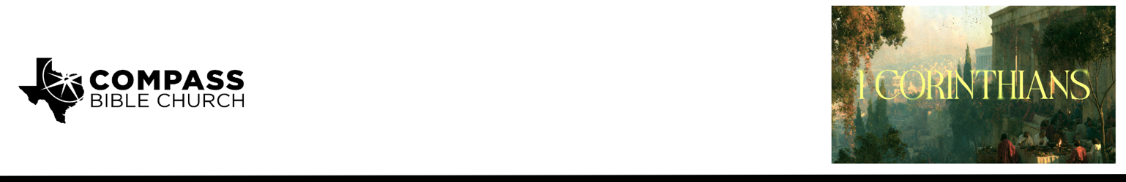

Pastor PJ Berner • September 20, 2026

1 Corinthians 1:30-31 | What's the Big Deal about Being in Christ?

Scripture Memory
And because of him you are in Christ Jesus, who became to us wisdom from God, righteousness and sanctification and redemption, so that, as it is written, “Let the one who boasts, boast in the Lord.” – 1 Corinthians 1:30-31

Application Questions
Community Groups meet throughout the week and play a crucial role in our response to the preaching of the word. These groups gather to discuss the following questions as we seek to apply the sermon in community with one another. Please visit compassntx.org to join a small group near you.

1. Read 1 Corinthians 1:30 and Ephesians 1:3–14. What does it mean for a Christian to be “in Christ”? Which of the blessings associated with being in Christ do you most easily take for granted, and why?

2. Read 1 Corinthians 1:30 and 6:11. Paul says that Christ has become our “righteousness and sanctification and redemption.” How should each of these realities change the way you think about both your standing before God and the way you live this week?

3. Read 1 Corinthians 1:31 and Jeremiah 9:23–24. What does it practically look like to “boast in the Lord”? How should boasting in Christ affect the way you talk about your successes, accomplishments, family, or other good things God has given you?

4. Read Philippians 3:3–11. Paul could point to an impressive résumé but considered it worthless as a basis for confidence compared with being “found in” Christ. If you were writing your own Philippians 3 résumé, what would be on it? Which item would be hardest for you to lose without feeling like you had lost part of your identity?

5. Pastor PJ said, “The most important thing about you is whether or not you are in Christ.” If that is true, where should that reality be more evident in your life right now? What is one specific change you could make this week so that your identity and confidence in Christ are more visible?

Recommended Reading

Here are some books that may assist you in a deeper study of the truths presented in today’s sermon. While we cannot endorse every concept presented in each book, we do believe these resources will be helpful in profitably thinking through today’s topic.

• The Devoted to God - Sinclair Ferguson
• Rejoicing in Christ - Michael Reeves
• The Gospel According to Jesus - John MacArthur

