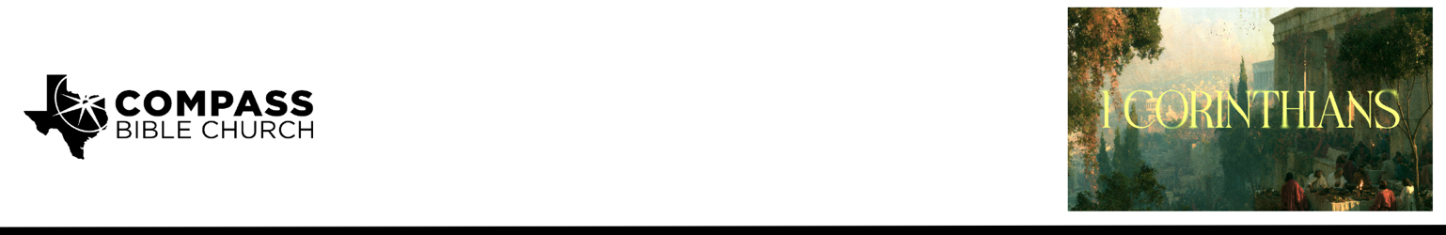

Pastor PJ Berner • September 13, 2026

1 Corinthians 1:26-29 | Your Story, God's Glory

Scripture Memory
And because of him you are in Christ Jesus, who became to us wisdom from God, righteousness and sanctification and redemption, so that, as it is written, “Let the one who boasts, boast in the Lord.” – 1 Corinthians 1:30-31

Application Questions
Community Groups meet throughout the week and play a crucial role in our response to the preaching of the word. These groups gather to discuss the following questions as we seek to apply the sermon in community with one another. Please visit compassntx.org to join a small group near you.

1. Read 1 Corinthians 1:26. Why are we naturally impressed when someone wealthy, powerful, famous, or influential becomes a Christian? What does that reaction reveal about how we measure someone's potential usefulness to God? How should Paul's command to “consider your calling” correct that way of thinking?

2. Read 1 Corinthians 1:27–28 and Deuteronomy 7:6–11. How should understanding the way God chooses His people change the way we evaluate other people? What worldly standards of significance are you most tempted to bring into the church? How might those standards affect whom you respect, pursue relationships with, listen to, or overlook?

3. Read 1 Corinthians 1:29 and 1 Timothy 1:12–17. We often prefer to tell stories that make us look good, but Paul repeatedly told a story that made him look terrible and Christ look great. Why was Paul so willing to talk openly about who he had been? How can we tell the story of God's work in our lives without either glorifying our past sin or sanitizing it in order to protect our reputation?

4. What is your 15-second testimony? Using the framework “There was a time in my life when... But God... Now I am...,” take a moment to formulate it, then share it with your group. How does your testimony make God rather than you the hero of your story?

Recommended Reading

Here are some books that may assist you in a deeper study of the truths presented in today’s sermon. While we cannot endorse every concept presented in each book, we do believe these resources will be helpful in profitably thinking through today’s topic.

• The Honor of God — Grant Castleberry
• The Gospel Shaped Life — Ian Hamilton
• Holiness by Grace — Bryan Chapell

