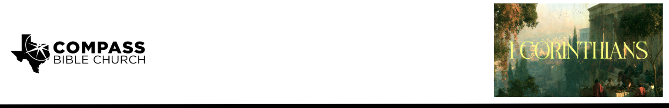

Pastor PJ Berner • September 6, 2026

1 Corinthians 1:21-25 | The Foolishness of God

Scripture Memory
And because of him you are in Christ Jesus, who became to us wisdom from God, righteousness and sanctification and redemption, so that, as it is written, “Let the one who boasts, boast in the Lord.” – 1 Corinthians 1:30-31

Application Questions
Community Groups meet throughout the week and play a crucial role in our response to the preaching of the word. These groups gather to discuss the following questions as we seek to apply the sermon in community with one another. Please visit compassntx.org to join a small group near you.

1. Read 1 Corinthians 1:21–23. The Jews wanted signs, and the Greeks wanted wisdom, but God gave them “Christ crucified.” What expectations have you placed on God—about your family, career, health, finances, future, or something else—that He has never actually promised? How can those expectations distort the way you evaluate God's goodness or faithfulness?

2. Read 1 Corinthians 1:23–24. Think back to your own conversion. What once seemed foolish, unnecessary, or difficult to accept about Christianity that you now recognize as the wisdom and power
of God? How does remembering that change encourage you as you pray for someone who currently
rejects Christ?

3. Read 1 Corinthians 1:23–24 and Galatians 3:1–3. Where are you most tempted to measure your standing with God by your own performance—your obedience, spiritual disciplines, ministry, parenting, or something else? How does “Christ crucified” correct that way of thinking?

4. Read 1 Corinthians 1:25 and Colossians 2:13–15. Where in your life right now does God’s way seem confusing, weak, or different from what you would have chosen? How should the cross—where apparent defeat was actually God’s victory—change the way you view that situation?

Recommended Reading

Here are some books that may assist you in a deeper study of the truths presented in today’s sermon. While we cannot endorse every concept presented in each book, we do believe these resources will be helpful in profitably thinking through today’s topic.

• God is the Gospel — John Piper
• Evangelism and the Sovereignty of God — J.I. Packer
• Redemption Accomplished and Applied — John Murray
• The Bondage of the Will — Martin Luther

