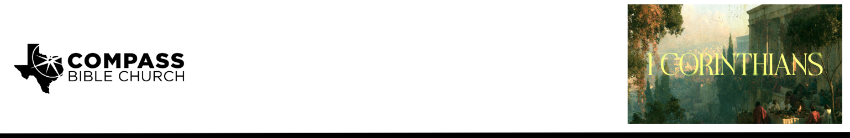

Pastor Rod Gomez • August 30, 2026

1 Corinthians 1:18–20 | Why Unbelievers Won’t Listen and
Why That Shouldn’t Stop You From Sharing the Gospel Anyway

Scripture Memory
And because of him you are in Christ Jesus, who became to us wisdom from God, righteousness and sanctification and redemption, so that, as it is written, “Let the one who boasts, boast in the Lord.” – 1 Corinthians 1:30-31

Application Questions
Community Groups meet throughout the week and play a crucial role in our response to the preaching of the word. These groups gather to discuss the following questions as we seek to apply the sermon in community with one another. Please visit compassntx.org to join a small group near you.

1. Read 1 Corinthians 1:17–18. What are some ways Christians today try to make the gospel sound more credible or less embarrassing and offensive, and, according to v.17, what does Paul say is at stake when we do so?

2. Read 1 Corinthians 1:18–20. Paul says the gospel is folly (moronic!) to those who are perishing. Where have you recently seen or heard Christianity mocked or disparaged? According to v.18, what does that mockery tell you about the person mocking, and what does it not tell you about the message?

3. Read Romans 1:16. When you picture bringing up Christ with one specific person you'll see this week, what are you actually afraid of losing, and why is it still worth the risk?

4. What training or strategies have you found most helpful in sharing the Gospel with others? What's your best advice to get past the awkwardness of moving a conversation toward the Gospel?

5. Read 1 Peter 3:15–16. What would you actually say if someone told you to your face that believing in a crucified Savior is ridiculous?

For private reflection:
Compass, how is your evangelism going?

If not well, what prevents you from making the gospel a priority in your relationships? Prayerfully inspect your heart before the Lord and ask him to expose the subtle idolatries that hold you back. Confess and repent before the Lord, and commit to one name and one step this week.

If it is going well, ask the Lord to keep you humble and hungry for more. Pray also for your church family who long to be more faithful in this area, that God would make them zealous evangelists (Matt 9:38)!

Recommended Reading

Here are some books that may assist you in a deeper study of the truths presented in today’s sermon. While we cannot endorse every concept presented in each book, we do believe these resources will be helpful in profitably thinking through today’s topic.

• Bonhoeffer, Dietrich. The Cost of Discipleship. Touchstone, 1995.
• Fabarez, Mike. “Sharing the Gospel with People Who Need It.” Ch. 9 in The Partners Manual. Compass Press.
• Gilbert, Greg. What Is the Gospel? Crossway, 2010.
• MacArthur, John. The Gospel According to Jesus: What Is Authentic Faith? Rev. ed. Zondervan, 2008.
• Metzger, Will. Tell the Truth: The Whole Gospel Wholly by Grace, Communicated Truthfully and Lovingly. 4th ed.
InterVarsity Press, 2012.
• Vincent, Milton. A Gospel Primer for Christians: Learning to See the Glories of God's Love. Focus Publishing, 2008.

