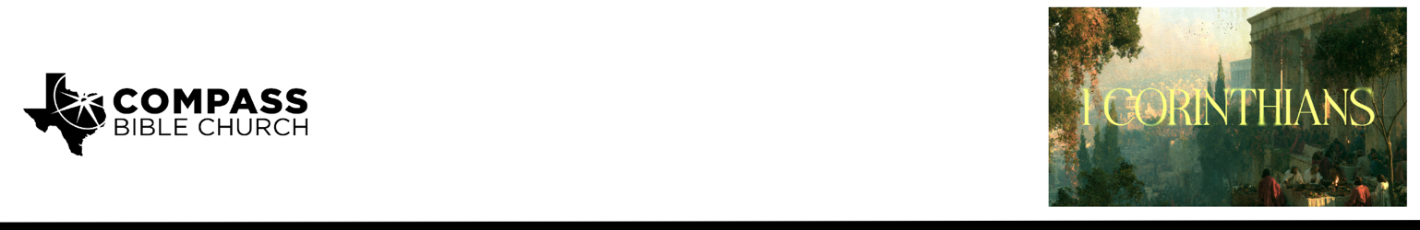

Pastor PJ Berner • August 23, 2026

1 Corinthians 1:10-17 | Fight Together: The Battle Worth Fighting

Scripture Memory
“For the word of the cross is folly to those who are perishing, but to us who are being saved it is the power
of God.” – 1 Corinthians 1:18

Application Questions
Community Groups meet throughout the week and play a crucial role in our response to the preaching of the word. These groups gather to discuss the following questions as we seek to apply the sermon in community with one another. Please visit compassntx.org to join a small group near you.

1. Read 1 Corinthians 1:10 and Philippians 1:27. Why is unity an expected or assumed byproduct of a church that accurately understands the gospel?

2. Read 1 Corinthians 1:10. What is the difference between unity and uniformity? What kinds of differences can Christians within a local church live with while remaining united? When might a disagreement become significant enough that leaving a church in charity actually serves the unity and mission of both the individual and the church?

3. What are some subtle ways we can contribute to disunity within a church without realizing it? When we sense division developing between people in the church, what would it look like to be someone who “mends the net” rather than making the tear larger?

4. Read 1 Corinthians 1:12–13. We have an abundance of resources through podcasts, apps, books, and sermons from faithful teachers. How can we steward these resources well while guarding against becoming overly fixated on a preacher rather than the Savior he serves? What are some signs that appreciation for a particular teacher has begun to become an unhealthy allegiance?

5. Read 1 Corinthians 1:17. Paul refused to allow secondary matters to distract him from proclaiming the gospel. What are some things that can distract a church from its gospel mission today? How can division within a church hinder that mission, and what can we do individually to help keep the gospel central?

Recommended Reading

Here are some books that may assist you in a deeper study of the truths presented in today’s sermon. While we cannot endorse every concept presented in each book, we do believe these resources will be helpful in profitably thinking through today’s topic.

• Finding the Right Hills to Die On - Gavin Ortlund
• The Compelling Community - Mark Dever
• The Peacemaker - Ken Sande

