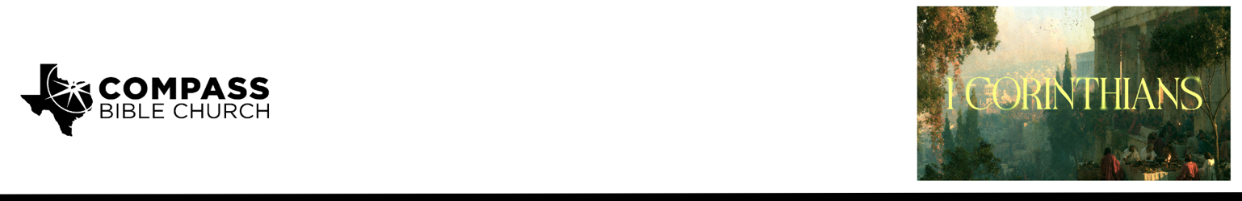

Pastor PJ Berner • August 16, 2026

1 Corinthians 1:4-9 | Where Is Your Boast? Grace, the Thief of Human Boasting

Scripture Memory
“For the word of the cross is folly to those who are perishing, but to us who are being saved it is the power
of God.” – 1 Corinthians 1:18

Application Questions
Community Groups meet throughout the week and play a crucial role in our response to the preaching of the word. These groups gather to discuss the following questions as we seek to apply the sermon in community with one another. Please visit compassntx.org to join a small group near you.

1. Read 1 Corinthians 1:4-6. Paul's thanksgiving is rooted entirely in what God had done in the Corinthians, not what they had done for God. When you reflect on your own testimony, do you find it easier to give God credit or to quietly take some credit yourself? What helps you keep the focus where Paul kept his?

2. Read 1 Corinthians 12:14-20. Paul says the Corinthians lacked "no gift" - not every gift, but everything needed for their mission. Do you know what spiritual gift(s) God has given you, and are you currently using them within the body? If not, what's holding you back?

3. Pastor PJ warned that a church can be tempted to boast in its numbers, doctrine, ministries, or the giftedness of its people. As you look at our attendance, our teaching, our community groups, and our outreach events, how would you help a fellow believer see those things rightly - as evidence of grace rather than accomplishments to be proud of?

4. Read 1 Corinthians 1:8-9. Paul grounds the Corinthians' confidence not in their faithfulness but in God's: "God is faithful." Where are you most tempted to base your confidence before God on your own performance? How does God's promise to sustain his people "to the end" change the way you think about your failures, struggles, or fears about the future?

5. Pastor PJ closed with: "It's His past grace that saves, His present grace that equips, and His future grace that will sustain us through until the end." Which of these three - saving, equipping, or sustaining grace - do you find yourself forgetting or undervaluing most often, and why?

Recommended Reading

Here are some books that may assist you in a deeper study of the truths presented in today’s sermon. While we cannot endorse every concept presented in each book, we do believe these resources will be helpful in profitably thinking through today’s topic.

• The Whole Christ - Sinclair Ferguson
• Saved Without a Doubt - John MacArhtur
• The Gospel-Driven Life - Michael Horton

