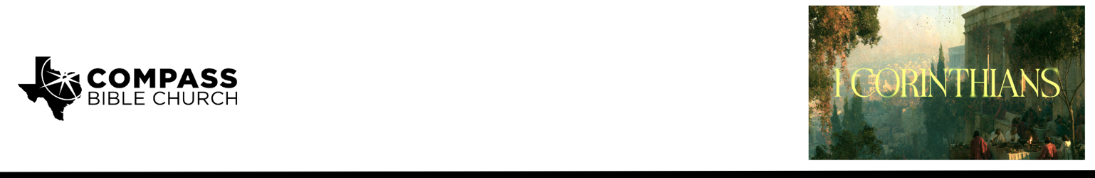

Pastor PJ Berner • August 9, 2026

1 Corinthians 1:1-3 | What is the Church? Setting the Foundation for What's Ahead

Scripture Memory
“For the word of the cross is folly to those who are perishing, but to us who are being saved it is the power
of God.” – 1 Corinthians 1:18

Application Questions
Community Groups meet throughout the week and play a crucial role in our response to the preaching of the word. These groups gather to discuss the following questions as we seek to apply the sermon in community with one another. Please visit compassntx.org to join a small group near you.

1. Read 1 Corinthians 1:1-3. Paul opens by defining the church before he begins correcting it. Why do you think it matters that Paul establishes what the church is before addressing what's wrong with it?

2. Read Acts 20:28 and 1 Corinthians 3:9. The church belongs to God, not to any pastor, personality, or long-tenured member. Have you ever caught yourself treating the church (or a ministry within it) as "mine" in a way that resisted change? What would it look like to hold this place more open-handedly?

3. Read Romans 8:30. Paul calls believers "those sanctified in Christ Jesus," set apart by God for His use, distinct from justification but tied to it. How does understanding yourself as sanctified (set apart), and not just forgiven, change how you think about your daily life and usefulness to God?

4. Pastor PJ said, "You can go to church and not be saved, you can participate in church and not be saved, but you can't truly be part of the church until you are saved." How would you explain the difference between attending church and belonging to the church to someone who's never thought about the distinction?

5. Roy Ciampa wrote, "A church that is aware of its connection to the church universal is less likely to be absorbed in its own problems." Corinth's biggest issues were factions and division. In what ways might our own community group, ministry team, or friend group be tempted toward a similar us-vs-them mindset?

Recommended Reading

Here are some books that may assist you in a deeper study of the truths presented in today’s sermon. While we cannot endorse every concept presented in each book, we do believe these resources will be helpful in profitably thinking through today’s topic.

• The Church: The Gospel Made Visible - Mark Dever
• Sojourners and Strangers: The Doctrine of the Church - Gregg Allison
• The Church in God's Program - Robert Saucy
• Life Together - Dietrich Bonhoeffer

