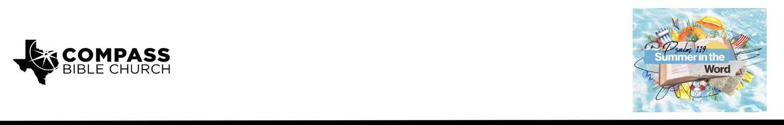

Pastor PJ Berner • August 2, 2026

Psalm 119:169-176 | Can YOU Trust God?

Scripture Memory
“For the word of the cross is folly to those who are perishing, but to us who are being saved it is the power
of God.” – 1 Corinthians 1:18

Application Questions
Community Groups meet throughout the week and play a crucial role in our response to the preaching of the word. These groups gather to discuss the following questions as we seek to apply the sermon in community with one another. Please visit compassntx.org to join a small group near you.

1. Read Psalm 119:169-170. The psalmist brought his cry straight to the Lord, confident that God alone could help. When have you experienced God providing for a need in a way that no one else could? How has that experience specifically strengthened your trust in Him during difficult times since then?

2. Read 2 Peter 1:19-21 and 1 Corinthians 2:9-16. God didn't just give us His Word; He gave us His Spirit to help us understand it. Describe a time the Holy Spirit made a passage of Scripture come alive to you or made it click for you in a way it hadn't before. How did that encourage your confidence in the Lord?

3. Read Psalm 119:173-174, Deuteronomy 10:14, and Psalm 24:1. Every resource in heaven and earth belongs to God. Hudson Taylor once said, "I could not think that God was poor." How does remembering God's unlimited resources change the way you bring your needs to Him in prayer? What does this do to your perspective on "unanswered" prayers?

4. Read Psalm 119:175-176. The picture here is of a shepherd who comes looking for his sheep, not a sheep that finds its own way home. How have you experienced God seeking you and bringing you back when you have gone astray?

5. As we conclude our series in Psalm 119, what are a few of your takeaways?

Recommended Reading

Here are some books that may assist you in a deeper study of the truths presented in today’s sermon. While we cannot endorse every concept presented in each book, we do believe these resources will be helpful in profitably thinking through today’s topic.

• We Become What We Worship - G.K. Beale
• Hudson Taylor's Spiritual Secret - Dr. Howard Taylor
• Gentle and Lowly - Dane Ortlund

