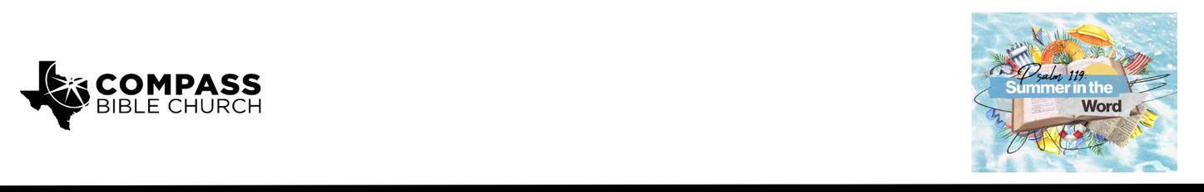

Pastor PJ Berner • July 12, 2026

Psalm 119:49-56 | What Good is God's Word?

Scripture Memory
“Consider how I love your precepts! Give me life, O LORD, according to your steadfast love. The sum of your word is truth, and every one of your righteous rules endures forever.”
– Psalm 119:159-160

Application Questions
Community Groups meet throughout the week and play a crucial role in our response to the preaching of the word. These groups gather to discuss the following questions as we seek to apply the sermon in community with one another. Please visit compassntx.org to join a small group near you.

1. Before hearing this sermon, how would you have described the practical value of God's Word in your life?

2. Read Psalm 119:49. Why do you think the author asks God to remember His Word? If you're comfortable sharing, have you ever prayed for God to remember His promises, and how did that bring comfort to you?

3. Read Psalm 119:53 and Ephesians 4:26. How can we express righteous indignation or anger with sin while still showing love and grace to the sinner? Should we always show love and grace toward the sinner? Why or why not?

4. Read Psalm 119:54. What are some of your favorite songs to turn to for comfort, and what biblical truths do they remind you of? What qualities do you think we should look for in the worship music we enjoy?

5. What is one practical change you feel led to make after hearing this sermon?

Recommended Reading

Here are some books that may assist you in a deeper study of the truths presented in today’s sermon. While we cannot endorse every concept presented in each book, we do believe these resources will be helpful in profitably thinking through today’s topic.

• If God is Good - Randy Alcorn
• Taking God at His Word - Kevin DeYoung
• The Valley of Vision - ed. Arthur Bennett

