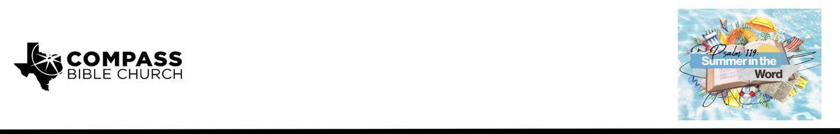

Pastor Marc Cogan • June 28, 2026

Psalm 119:89-96 | What Stands Forever?

1. _____________________________________________________________

2. _____________________________________________________________

3. _____________________________________________________________

Scripture Memory
“Consider how I love your precepts! Give me life, O LORD, according to your steadfast love. The sum of your word is truth, and every one of your righteous rules endures forever.”
– Psalm 119:159-160

Application Questions
Community Groups meet throughout the week and play a crucial role in our response to the preaching of the word. These groups gather to discuss the following questions as we seek to apply the sermon in community with one another. Please visit compassntx.org to join a small group near you.

1. Read Psalm 119:89-91. Why should you seek to know more about who God is and his character? If God is who he says he is and his words are fixed, then how should that change how you live?

2. Focus on Psalm 119:90. How is God able to be perfectly faithful to all generations? Give some practical examples of what your life would be like if God wasn’t faithful in such a way.

3. Read Psalm 119:92-93. God has spoken to us, but how do you remind yourself of what he’s said? What happens when you remind yourself of the gospel after you have sinned? What happens when you remind yourself of the gospel when you are having a good day?

4. Read Matthew 11:28-29 and Revelation 21:3-4. How is it possible that these promises aren’t just wishful thinking from God? How are these promises absolutely sure? What is one habit you can start developing this week to remind yourself of his sure promises?

Recommended Reading

Here are some books that may assist you in a deeper study of the truths presented in today’s sermon. While we cannot endorse every concept presented in each book, we do believe these resources will be helpful in profitably thinking through today’s topic.

Packer, J.I. Knowing God. InterVarsity Press, 1973.
DeYoung, Kevin. Taking God at His Word: Why the Bible Is Knowable, Necessary, and Enough. Crossway, 2014.
Waters, Guy Prentiss. For the Mouth of the Lord Has Spoken: The Doctrine of Scripture. Christian Focus, 2021.
Whitney, Donald S. Spiritual Disciplines for the Christian Life. Rev. ed. NavPress, 2014.

