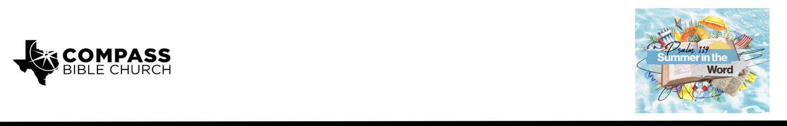

Pastor Rod Gomez • June 21, 2026

Psalm 119:97-104 | Love Meditates, Wisdom Follows

Scripture Memory
“Incline my heart to your testimonies, and not to selfish gain! Turn my eyes from looking at worthless things; and give me life in your ways.”
– Psalm 119:36-37

Application Questions
Community Groups meet throughout the week and play a crucial role in our response to the preaching of the word. These groups gather to discuss the following questions as we seek to apply the sermon in community with one another. Please visit compassntx.org to join a small group near you.

1. Read Psalm 119:97. What do you notice about how the psalmist describes his relationship to God’s Word (think: tone, emotion, frequency)? Many of us relate to Scripture more as a duty than a delight; what do you think makes the difference between the two?

2. Read Psalm 119:98–100. The psalmist credits his wisdom to meditation rather than talent. Our culture pours enormous energy into improving the “outer man.” Why do you think age-defying wisdom is such a harder sell than age-defying strength or beauty, even for Christians?

3. Read Psalm 119:101. Notice the timing of the verb: “I hold back my feet” happens before the step, not after. Why is prevention so much harder to practice than cure? Where might meditation help someone spot an “evil way” earlier than they otherwise would?

4. Read Psalm 119:102 and Proverbs 14:12. The psalmist calls God’s rules something he won’t “turn aside” from, because they’ve proven to be guardrails rather than fences. Can you think of a command of God that people often experience as restrictive at first but come to see as protective? What changes that perception over time?

5. Read Psalm 119:103–104. The psalmist’s trained palate finds God’s Word sweet and false ways bitter. How does a “taste” for something form or dull over time? Where do you see this principle at work in food, habits, or relationships, and what might it look like for our taste for Scripture?

Recommended Reading

Here are some books that may assist you in a deeper study of the truths presented in today’s sermon. While we cannot endorse every concept presented in each book, we do believe these resources will be helpful in profitably thinking through today’s topic.

DeYoung, Kevin. Taking God at His Word: Why the Bible Is Knowable, Necessary, and Enough. Crossway, 2014.
McCracken, Brett. The Wisdom Pyramid: Feeding Your Soul in a Post-Truth World. Crossway, 2021.
Morgan, Robert J. Reclaiming the Lost Art of Biblical Meditation: Find True Peace in Jesus. Thomas Nelson, 2017.
Piper, John. Reading the Bible Supernaturally: Seeing and Savoring the Glory of God in Scripture. Crossway, 2017.
Saxton, David W. God's Battle Plan for the Mind: The Puritan Practice of Biblical Meditation. Reformation Heritage Books, 2015.
Whitney, Donald S. Spiritual Disciplines for the Christian Life. Rev. ed. NavPress, 2014.

