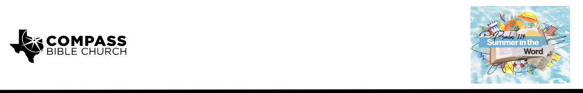

Pastor PJ Berner • June 7, 2026

Psalm 119 (various)
Untapped Joy: Discovering unrivaled joy in the pages of God's Word

Scripture Memory
“Incline my heart to your testimonies, and not to selfish gain! Turn my eyes from looking at worthless things; and give me life in your ways.”
– Psalm 119:36-37

Application Questions
Community Groups meet throughout the week and play a crucial role in our response to the preaching of the word. These groups gather to discuss the following questions as we seek to apply the sermon in community with one another. Please visit compassntx.org to join a small group near you.

1. Read Psalm 119:1–3 and Psalm 32:1–5. How would you describe the difference between the objective cleansing of our conscience in Christ (what God has done once for all) and the subjective experience of a clear conscience in daily life? How have you personally seen a guilty conscience
rob you of joy, and what blessings have you tasted when walking with a clear conscience before
the Lord?

2. Read Psalm 119:44–45. Think of a specific season when obeying God’s Word was costly or hard, yet you experienced a surprising joy or sense of “walking in a wide place” as you persevered. What sustained you in that season, and what did you learn about the link between obedience and joy?

3. Read Psalm 119:165, 114, and 76. When you are in need of peace, hope, or comfort, which specific passages do you most often turn to, and why? Share one practical example of a time when God met you through those verses more deeply than through any “comfort” or “hope” the world was offering (news, entertainment, relationships, possessions, etc.).

4. Of the five “veins of joy” we considered—a clear conscience, perseverance, peace, hope, and comfort in God’s Word—which one do you sense the Lord pressing on most in your life right now? What would it look like, practically, to pursue that particular joy in the Scriptures this week?

Recommended Reading

• Discovering the Joy of a Clear Conscience - Christopher Ash
• Future Grace - John Piper
• A Place of Healing - Joni Eareckson Tada
• The Saint’s Everlasting Rest - Richard Baxter

