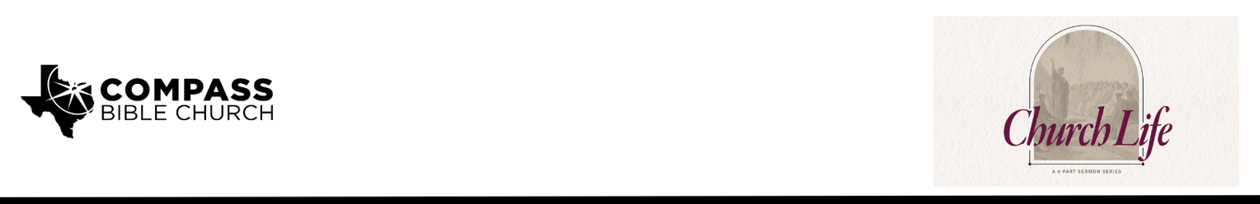

Pastor PJ Berner • May 3, 2026

1 Peter 5:10-11 | The Secret to Lasting Strength

Scripture Memory
“Humble yourselves, therefore, under the mighty hand of God so that at the proper time he may exalt you, casting all your anxieties on him, because he cares for you.”
– 1 Peter 5:6-7

Application Questions
Community Groups meet throughout the week and play a crucial role in our response to the preaching of the word. These groups gather to discuss the following questions as we seek to apply the sermon in community with one another. Please visit compassntx.org to join a small group near you.

- Read 1 Peter 5:10 and Romans 8:18. When you’re in a trial right now, what practical things help you zoom out and remember God’s eternal perspective (for example, habits, verses, people, or practices)?

- Read 1 Peter 5:10–11 and 1 Corinthians 10:13. When you suffer, what worldly ‘comforts’ or escapes are you most tempted to run to (e.g., distraction, substances, entertainment)? How can remembering that God Himself will restore, confirm, strengthen, and establish you change the way you respond this week?

- Share one passage you regularly turn to in suffering, and read it aloud. How does God use that passage to either restore you, confirm you, strengthen you, or establish you?

- Read 1 Peter 5:11 and 1 Thessalonians 5:16–18. How does knowing that God has ‘dominion forever and ever’ help you rejoice and give thanks even in hard circumstances? Can you share a time when a painful situation eventually became something you can now praise God for—or, if you are not there yet, how you are trying to trust Him in the middle of it?

Recommended Reading

• The Hiding Place - Corrie ten Boom
• Through the Gates of Splendor - Elizabeth Elliot
• Trusting God - Jerry Bridges

