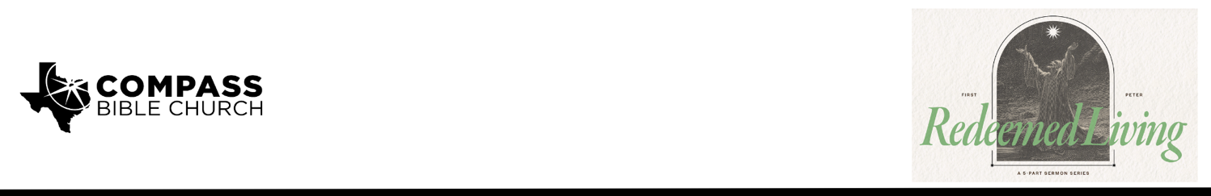

Pastor PJ Berner • March 22, 2026

1 Peter 4:17-19 | Don't Be a Deist: Entrusting Our Souls to a Faithful Creator

1. Expect __________________________________________________________ (17a)

2. Think ________________________________________________________ (17b-18)

3. Respond _________________________________________________________ (19)

Scripture Memory
“Beloved, do not be surprised at the fiery trial when it comes upon you to test you, as though something strange were happening to you. But rejoice insofar as you share Christ’s sufferings, that you may also rejoice and be glad when his glory is revealed.”
– 1 Peter 4:12-13

Application Questions
Community Groups meet throughout the week and play a crucial role in our response to the preaching of the word. These groups gather to discuss the following questions as we seek to apply the sermon in community with one another. Please visit compassntx.org to join a small group near you.

1. Read 1 Peter 4:17 and Malachi 3:1–3. According to these passages, why does God begin His refining work with His own people? In light of this, what are some common ways the broader evangelical church can drift into compromise, comfort, or false trust that would invite God’s refining fire? Where do you see your own heart and our corporate life at Compass potentially needing God’s refining (e.g., love for the world, complacency in sin, diluted gospel, trust in comfort or reputation)? Guideline: Focus on patterns and your own heart, not on specific individuals or recent conflicts. Frame your answers as prompts for prayer, not as complaints.

2. Read 1 Peter 4:17b–18 and Matthew 25:46. How does a clear, biblical understanding of hell shape the way you think about your own sin and your pursuit of holiness? In what specific ways
can meditating on the reality of hell deepen your fear of God and strengthen your resolve to live a godly life?

3. Read 1 Peter 4:19. In the sermon, Pastor PJ warned about the danger of becoming “functional deists” when we suffer—believing God knows about our pain but is distant and uninvolved. Peter instead calls God “a faithful Creator.” What does this title reveal about God’s relationship to your suffering? How does remembering Him as your Creator help you entrust your soul to Him in the specific trials you’re facing right now?

4. Read 1 Peter 4:19. According to this verse, why is ‘doing good’ inseparable from entrusting ourselves to our faithful Creator—especially when doing good may bring more suffering? George Whitefield said, ‘I would rather wear out than rust out.’ What does that look like in everyday
church life, and what is one concrete area where God may be calling you to ‘wear out’ a little
more for His sake?

Recommended Reading

• The Knowing God - J.I. Packer
• Hell Under Fire - Christopher Morgan and Robert Peterson
• God’s Sovereignty and Man’s Responsibility - R.C. Sproul

