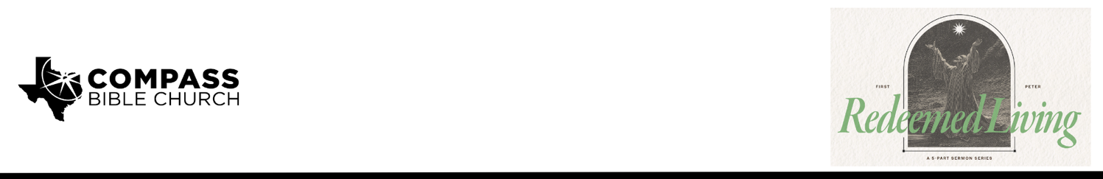

Pastor PJ Berner • March 1, 2026

1 Peter 4:1-2 | What to Expect When You Are Expecting

1. Embrace _________________________________________________________ (1a)

2. Find _____________________________________________________________ (1b)

3. Be _______________________________________________________________ (2)

Scripture Memory
“Beloved, do not be surprised at the fiery trial when it comes upon you to test you, as though something strange were happening to you. But rejoice insofar as you share Christ’s sufferings, that you may also rejoice and be glad when his glory is revealed.”
– 1 Peter 4:12-13

Application Questions
Community Groups meet throughout the week and play a crucial role in our response to the preaching of the word. These groups gather to discuss the following questions as we seek to apply the sermon in community with one another. Please visit compassntx.org to join a small group near you.

1. Read 1 Peter 4:1 and Colossians 3:1-2. What does setting our minds on the things above rather than the things on earth do for our readiness to suffer? What does seeking the things above look like for you in your various roles (parent, spouse, single, student, employee, neighbor)?

2. We often think of suffering for our faith as persecution, but what are some other ways you should be suffering for your faith in the choices or decisions you make for yourself and your family that are a consequence of your relationship with Christ? (Think purpose, entertainment, goals for children, career advancement, church involvement, etc.)

3. Read 1 Peter 4:1, 1 Peter 1:6-7, and John 15:18-19. How does the Bible portray suffering for our faith as something that should confirm our faith rather than discourage us? How might you adopt that perspective on the trial you are facing such that it should become a source of encouragement rather than doubt?

4. Read 1 Peter 4:2 and 2 Cor 5:15. How can you know if you are living for human passions instead of the will of God? Can pursuing a non-sinful passion (safety, health, family) be at odds with the will of God? How would you know?

Recommended Reading

• Light from Old Times - J.C. Ryle
• The Cost of Discipleship - Dietrich Bonhoeffer
• The Crook in the Lot - Thomas Boston

