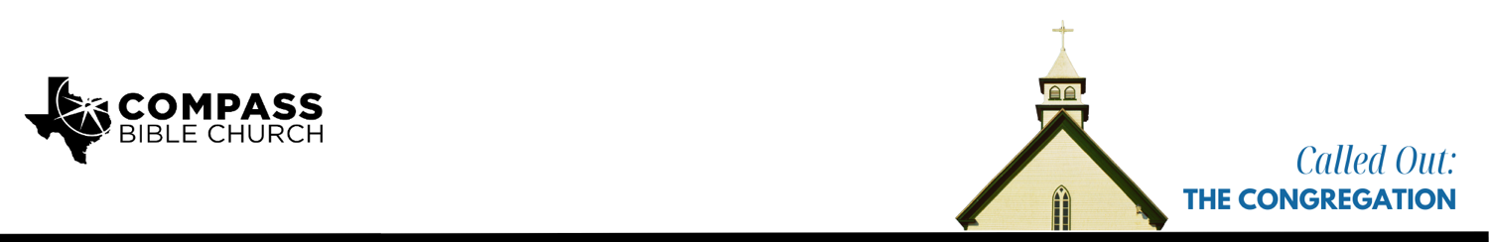

Pastor PJ Berner • January 11, 2026

Ephesians 4:11-16 | Called Out: The Congregation

1. Gather __________________________________________________________ (11)

2. Value _________________________________________________________ (12-14)

3. Commit _______________________________________________________ (15-16)

Scripture Memory
And let us consider how to stir up one another to love and good works, not neglecting to meet together, as is the habit of some, but encouraging one another, and all the more as you see the Day drawing near.
–Hebrews 10:24-25

Application Questions
Community Groups meet throughout the week and play a crucial role in our response to the preaching of the word. These groups gather to discuss the following questions as we seek to apply the sermon in community with one another. Please visit compassntx.org to join a small group near you.

1. Read Ephesians 4:11 and 1 Timothy 3:15. The Church’s role as the preserver and upholder of the authority of God’s word speaks to our need to be committed to a local church. What’s wrong with the mindset that says, “I don’t need the local church, I can study God’s word on my own and be just fine?”

2. How do you think the office of pastor is viewed in our culture today, and why should godly pastors be viewed as a gift from God to the local church?

3. Read Ephesians 4:12-14. From the sermon, what are the two primary benefits of gathering under the authority of God’s word accurately handled by faithful pastors? What threats do we face as a church from our surrounding culture, and how is your faith being strengthened here at Compass?

4. Read Ephesians 4:15-16. What does it mean for each part to be “working properly?” How are we robbing Christ of the worship He is due by not contributing to the body growing up “into him who is the head, into Christ?” How are you contributing toward this at Compass?

Recommended Reading

• Gospel Worship - Jeremiah Burroughs
• Why We Love the Church - Kevin DeYoung and Ted Kluck
• The Elder-Led Church - Murray Capill

