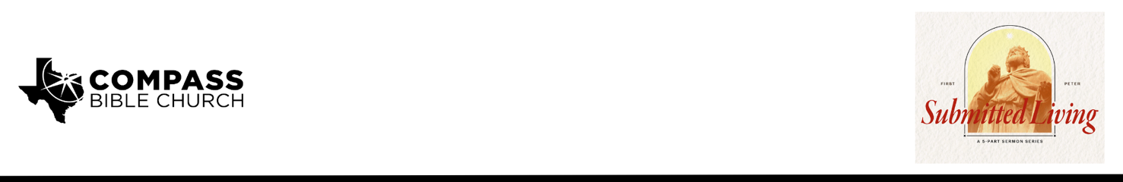

Pastor PJ Berner • November 2, 2025

1 Peter 2:18-20 | Just Do It: How Faith-Filled Submission Honors God and Earns His Well Done

1. Read _________________________________________________________ (18-20)

2. Submit __________________________________________________________ (18)

3. Catch ________________________________________________________ (19-20)

Scripture Memory
Like newborn infants, long for the pure spiritual milk, that by it you may grow up into salvation—if indeed you have tasted that the Lord is good. –1 Peter 2:2-3

Application Questions
Community Groups meet throughout the week and play a crucial role in our response to the preaching of the word. These groups gather to discuss the following questions as we seek to apply the sermon in community with one another. Please visit compassntx.org to join a small group near you.

1. Why is it important to read the Bible in the original context and not to just read into the Bible what we feel like it means to us today?

2. Read 1 Peter 2:18. What is a situation where you have had to submit to an unjust authority in your life? How does making that submission about God rather than man help your perspective in situations like that?

3. Read Ephesians 6:5-7. What does this passage say about the posture of your heart when it comes to submission? What should you do if you know you should submit, but you are struggling to bring your heart into a God-honoring posture of submission?

4. Read 1 Peter 2:19. How does the Christian’s submissive response to cruelty or suffering differ from that of the stoic philosophers who emphasize true freedom as mastering our emotional response to adversity?

5. Read 1 Peter 2:20 and Ephesians 6:8. If you were to pause in the midst of the difficult situation to ask yourself the question, “What about this situation will matter 100 years from now?”, how might that help you choose submission?

Recommended Reading

• Suffering and the Sovereignty of God edited by John Piper and Justin Taylor (2006)
• Slave: The Hidden Truth About Your Identity in Christ – John MacArthur (2010)
• Standing Firm When You’d Rather Run: Lessons from 1 Peter on Cultural Pressure – Abner Chou & Josiah Grauman (TMS professors, 2024) Co-authored TMS faculty work

