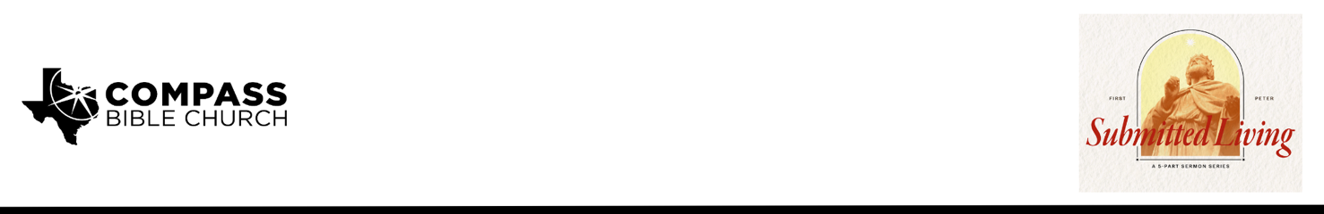

Pastor PJ Berner • October 26, 2025

1 Peter 2:13-17 | No King but Jesus: How Christians Should Approach Government

1. Recognize _____________________________________________________(13-14)

2. Submit________________________________________________________(13-16)

3. Prioritize_________________________________________________________(17)

Scripture Memory
Like newborn infants, long for the pure spiritual milk, that by it you may grow up into salvation—if indeed you have tasted that the Lord is good. –1 Peter 2:2-3

Application Questions
Community Groups meet throughout the week and play a crucial role in our response to the preaching of the word. These groups gather to discuss the following questions as we seek to apply the sermon in community with one another. Please visit compassntx.org to join a small group near you.

1. Read 1 Peter 2:13. How does man’s desire for government point to our being created in the image of God?

2. How involved should a Christian be in matters of government and politics? How would you answer the person who takes a more disinterested approach because they are more focused on being a citizen of heaven than a citizen of this world?

3. Read 1 Peter 2:13 and Proverbs 11:14. How does your conscience help you discern when it is okay to disobey an authority, be they civic, spiritual, or marital? How does being a committed participant in a church family help you discern whether or not your conscience is biblically informed in these matters?

4. Read 1 Peter 2:16. How can our freedom become a “cover-up for evil,” and how would you know? How can a biblically informed conscience help protect us against such dangers?

5. Read 1 Peter 2:16. How can we live as free and yet also as those who are servants of God? What does this have to do with our submission to governing authorities?

6. Read 1 Peter 2:17. What is the difference between showing honor to governing authorities and fearing God?

7. Check in on this month's Scripture memory passage, 1 Peter 2:2-3.

Recommended Reading
• Politics- According to the Bible - Wayne Grudem
• How the Nations Rage: Rethinking Faith and Politics in a Divided Age - Jonathan Leeman
• Conscience: What It is, How to Train It, and Loving Those Who Differ - Andrew David Naselli

