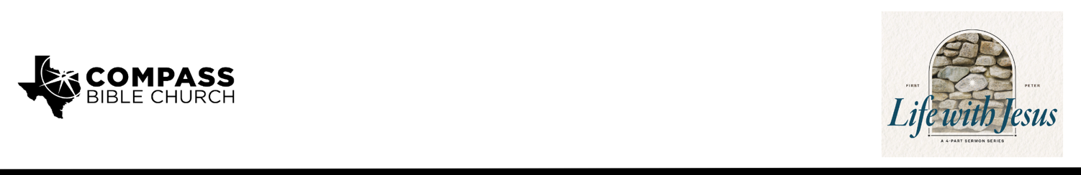

Pastor PJ Berner • October 12, 2025

1 Peter 2:9-10 | Church Perks: The Benefits of Belonging to the Body of Christ

1. Enjoy ___________________________________________________________ (9a)

2. Play ____________________________________________________________ (9b)

3. Remember ______________________________________________________ (10)

Scripture Memory
Like newborn infants, long for the pure spiritual milk, that by it you may grow up into salvation—if indeed you have tasted that the Lord is good. –1 Peter 2:2-3

Application Questions
Community Groups meet throughout the week and play a crucial role in our response to the preaching of the word. These groups gather to discuss the following questions as we seek to apply the sermon in community with one another. Please visit compassntx.org to join a small group near you.

1. Read 1 Peter 2:9. Which of the titles Peter employs to describe the church encourages you the most and why?

2. Read 1 Peter 2:9. Are these titles individual or corporate? How has the spirit of independence and individualism that has contributed so much to the progress of America been detrimental to our understanding of and approach to the Church?

3. Read 1 Peter 2:9. How might the seemingly benign and everyday conversations you have with your unbelieving friends or the way you treat the barista at your local coffee shop still be an example of proclaiming the excellencies of Christ, even if you don’t actually share the gospel?

4. What are some of the excellencies of Christ that you have experienced since becoming a believer?

5. Read 1 Peter 2:10. What is mercy, and how does it differ from grace? How does a believer
still need the mercy of God? How should the mercy we have received show up in how we treat
other people?

6. Check in on the memory verses for this month: 1 Peter 2:2-3.

Recommended Reading

• The Gospel According to God - John MacArthur
• The Gospel and Personal Evangelism - Mark Dever
• True Worshipers - Bob Kauflin
• The Bruised Reed - Richard Sibbes

