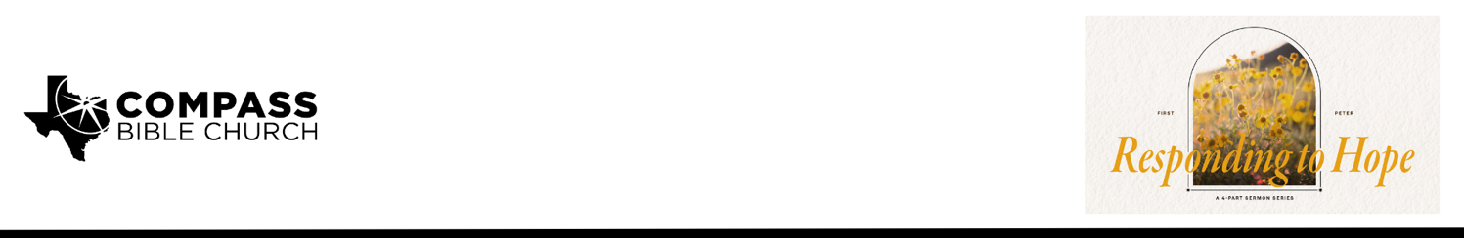

Pastor Rod Gomez • September 21, 2025

1 Peter 1:22–2:1 | Responding to Hope Part 4:
Family Living (How the Gospel Changes Your Relationships with Other Christians)

Scripture Memory
Therefore, preparing your minds for action, and being sober-minded, set your hope fully on the grace that will be brought to you at the revelation of Jesus Christ. –1 Peter 1:13

Application Questions
Community Groups meet throughout the week and play a crucial role in our response to the preaching of the word. These groups gather to discuss the following questions as we seek to apply the sermon in community with one another. Please visit compassntx.org to join a small group near you.
1. Read 1 Peter 1:22, 1 John 4:7-8, and 1 Thess 4:9-10. How do Peter, John, and Paul’s words confront the mindset that we are “loving enough,” and why must Christians never grow complacent in their love for Christ and his Church?

2. What happens to a church that pursues love for others without ensuring their definition of love is determined by Scripture, and how can you guard against these errors?

3. Read 1 Peter 1:23-25 and 1 John 4:19. In what ways does the gospel motivate, inform, and even demand our love for other Christians, and what implications does this have for your participation and involvement in church life?

4. Read 1 Peter 2:1 and Col 3:8-11 (the same Greek word underlies the imperative to “put away” in these verses). Why are these “private sins” so destructive for our public good, and what strategies will you use when you sense them growing in your heart or the heart of another?

5. What would a typical Sunday morning look like when a church is committed to “love one another earnestly from a pure heart”? Pray for this verse to characterize our church.

Recommended Reading

- When the Church Was a Family, Hellerman
- Life Together, Bonhoeffer
- The Gospel Comes with a House Key, Butterfield

